

# Executive Overview

Our proposal for The National Retirer is to provide a network infrastructure that meets the distinct needs of each of its three buildings. Building one consists of people involved in the editorial process, and building two is dedicated to management and maintenance positions, housing the Data Center. Building three has the executive headquarters and conference rooms.

Through our calculations the proposed design will accommodate for the bandwidth requirements based on usage, considering maintenance and redundancy. The physical components consist of modular switches and tiered configurations to enable future scalability. The switches are partitioned off the ports with VLANs, to separate the incoming traffic from all devices, preventing any collisions from occurring.

We encountered a few issues and had to consider the trade-offs of the possible decisions. For example, subnetting the addressing proved to be an issue. The address pools could not efficiently filter into the required space, resulting in a complex design. Despite the technically sufficient space, we implemented NAT for a more uniform and manageable logical network. We also choose to spend the most of the budget on the Data Center due to its crucial role it plays in network design and the high transmission rate it requires.

The total cost for implementing the suggested network infrastructure is:

1. Building One: $393,400 +
2. Building Two: $2,026,000 +
3. Building Three: $376,400 =

This results in the total cost of **$2,795,800**.

This cost will enable The National Retirer to meet its operational goals. This design also accounts for scalability so that the National Retirer can continue to be the nation’s premier tabloid magazine for upper-middle-aged office workers.

# 

# 

# 

# Detailed Proposal

## Section 1 – Problem Analysis

The task assigned to us is to design a network for The National Retirer. The National Retirer is comprised of three buildings each with their own specific needs.

Building one has the reporters, photographers, cameramen, and editors. It consists of two floors, with each floor having 200 users. The average rate of each user in the building is 300 Mbps with a peak of 450 Mbps. Management at The National Retirer does not place a high priority on video streaming.

Building Two has IT, HR, Finance, Legal, and the Data Center. It has a total of four floors. Floors two, three, and four each have 250 users each. Each user has an average of 320 Mbps and a peak of 450 Mbps. The Data Center is located on the first floor. Users from any building can access the Data Center via the network.

The Data Center has 12 dedicated disk servers each used to store backups, archives, and old magazine editions. These disk servers are only accessible by the 25 file/database servers through a private network. Each Disk server needs a bandwidth of 80 Gbps. According to the engineering team, only 75% of traffic going to and from the disk servers are disk-to-disk backups.

The Data Center also has 25 file/database servers that must be connected to the disk servers on the back end and the user network on the front end. Each server has one network interface card for back-end traffic which is a 40 Gbps interface. The front-end traffic of each server has four 10 Gbps interfaces.

Building Three has the Main Office, Conference Rooms, and Executive Suites. It consists of three floors each with its requirements. Floor one is a lobby with only 10 regular users on the floor, each having an average data rate of 100 Mbps. Floor two has 16 conference rooms, each room has 8 network drops. Each conference room will also have a video teleconferencing device that will require 1 Gbps of bandwidth, it should be on a separate network. Floor three has 56 executive offices, each office is required to have a 1 Gbps connection to the network.

Each user in the company has their own VoIP phone that is placed at their desk. Because the VoIP phones have Ethernet Passthrough, we do not have to use a port slot in our switches to connect them. A VLAN is used to separate the phone traffic from the rest of the network traffic. Each phone has a bandwidth of 100 Mbps.

The National Retirer requires at least one printer for every 25 users in buildings one and two. Each executive office has a printer. Each printer has a bandwidth of 50 Mbps and printer traffic must be separate from the rest of the network traffic.

Wireless access points are used by the company as a guest network. Thus, the wireless network should not be able to access any resources on the wired network. Buildings one and two should have one access point for every 25 users. The first floor of building three should have 8, each conference room should have one, and each executive office should have one as well.

The National Retirer already has a router and firewall. The LAN network must connect to the router and firewall. The device has eight 10 Gbps connections and four 40 Gbps connections.

The design must also include an IP addressing scheme. All broadcast domains should not be greater than 500 IPs. The IPv4 blocks provided to The National Retirer are 38.11.128.0/22, 38.11.132.0/22, and 38.11.136.0/22.

## 

## Section 2 – Problem Solution

To create the network, we will use a tiered switch approach. Each building will be on a switch that will connect to our root switch. The root switch, also known as the core, handles traffic between buildings, communication to the data center, and traffic flowing outside of the network.

A similar assumption can be made when considering the routers provided by the ISP. The bandwidth they offer may not support the entire network only if the peak is for all users on site.

Looking broadly at the VLAN portion of our network design, according to the network specifications there need to be separate VLANs for VoIP traffic, Wireless AP’s, Printers, and Teleconferencing Devices. A question that we need to ask is whether users should also be on a VLAN. Since we will need to designate trunk port(s) in switch-to-switch interfaces, we might as well put all of the users on VLANs according to building to ensure that all network traffic takes place on VLANs. While it makes sense to separate VLANs based on user role, that is not feasible in our network scenario because we are not given the specific numbers on how many users of a specific role are in a specific building. Instead, we will separate our user VLANs based on the building that the user is located in for organizational purposes. That way, we can also designate all switch-to-switch ports as trunk ports and all traffic can move across these interfaces because all traffic will be on VLANs.

**Physical Design**

**Building 1:**

To start our physical network design, we must first calculate how much bandwidth each building requires and decide what hardware to use accordingly. We will begin at Building 1. The first traffic to look at for Building 1 is the user traffic. There are 200 users per floor, with two floors in Building 1, there are 400 users total. First, we will calculate the bandwidth for the average demand rate of 300 Mbps per user. 400 (users) * 300 Mbps = 120,000 Mbps = 120 Gbps. Next, we will run the same calculations but with the peak bandwidth instead. The peak bandwidth for the 400 users is 450 Mbps, so 400 (users) * 450 Mbps = 180,000 Mbps * 2/3 (for oversubscription) = 120,000 Mbps = 120 Gbps. Since these two answers are identical, our final answer is pretty easy for the required user bandwidth, which is 120 Gbps.

For our 4 VLANs (other than users), we need to calculate the amount of bandwidth needed for all the combined VLAN traffic for each building to ensure our network design accommodates the trunk ports required between the buildings and the Core for VLAN traffic. For Building 1, we have as many VoIP phones as users so we have 400 VoIP phones at 100 Mbps per phone, therefore 100 * 400 = 40,000 Mbps = 40 Gbps required bandwidth for VoIP phones. Building 1 has 1 printer per 25 users so 400 (users) / 25 = 16 printers at 50 Mbps each, which is 16 * 50 = 800 Mbps = 0.8 Gbps. Additionally, there are 16 (also 1 per 25 users) Wireless AP’s in Building 1 at 200 Mbps each, which is 16 * 200 = 3,200 Mbps = 3.2 Gbps required. In total, for Building 1 there is 40Gbps + 0.8 Gbps + 3.2 Gbps = 44 Gbps.

In total, for Building 1, we need 164 Gbps of bandwidth to be accounted for in our network design. We will also need 400 (users) + 16 (printers) + 16 (WAP’s) = 432 switch ports to plug our devices into. One option to account for these requirements would be to install multiple fixed configuration switches on each floor and route them to another switch that is connected to the Core. In this scenario, we would want to use FC-SW-48T-LA switches because we need to support a large number of users. Since these switches can support 48 users each we could implement a total of 432 (total switch connections needed) / 48 = 9 switches required. If we divide our total bandwidth requirements by 9 switches, we get 164 Gpbs / 9 = 18.22 Gbps per switch. The backplane for the FC-SW-48T-LA supports that bandwidth, and running 2 fiber optic lines from the uplink ports on each switch would accommodate the required 18.22 Gbps since each uplink port supports 10 Gbps each. The problem begins to originate when we look at what switch these lines will be connecting to. Our only option for fixed configuration switches is to use the FC-SW-16F switch to run the fiber lines into, but we need 9 (# of switches) * 2 (# of lines required per switch) = 18 lines. Each of the FC-SW-16F switches only has 16 ports, so we would need 2 to support the 18 lines required. That would leave 14 ports open in the two switches, but we need to be able to send 164 Gbps of bandwidth to the Core from these switches, which (using 10G lines) would require 17 additional lines running to the Core. 17 more lines would mean we would need another of these switches, and then we would have to pay the heavy cost of running so many fiber lines. Additionally, if we used a chassis we could save money on the number of fiber lines run as well as use a MOD-LC-4F-40G which could run 160 Gbps of the bandwidth in only 4 fiber lines to the Core. Using 1 chassis for the building would be cheaper than using fixed configuration switches because it would save money on fiber connections and on switch costs from having to purchase 3 FC-SW-16F switches at $24,000 a piece since the MOD-LC-4F-40G switch gives us the same functionality for only $32,000.

For this new proposed configuration for Building 1, if we run all our lines from our users, printers, and WAP’s directly into the chassis, then we could save on cables by using the chassis backplane. To accomplish this, we will need to use the MOD-LC-48T switches. We do not need the MOD-LC-48T-LA or the MOD-LC-96T because link aggregation is not required for the user connections. 432 (total switch connections needed) / 48 (# of ports per switch) = 9 switches required. If we divide the bandwidth requirement by the number of switches, we get 164 Gbps / 9 = 18.22 Gbps per switch. The backplane on the MOD-LC-48T supports this bandwidth so the switch works. Additionally, we will need the largest chassis (MOD-SW-13) to support the 9 switches and a supervisor module (MOD-SW-SUP). To connect Building 1 to the Core, we will need to accommodate 164 Gbps of bandwidth. The easiest way to do this is to install one MOD-LC-4F-40G switch in the chassis, which supports 4 * 40 Gbps = 160 Gbps of link-aggregated bandwidth across its 4 ports. This is 4 Gbps short of our requirement, but it is unlikely that all of the required bandwidth will be used at the same time, and since the alternative would be to spend another $10,000 for a switch + $5,000 for another fiber line + $1,000 for manpower = $16,000 for a meager 4 Gbps of bandwidth, it is an acceptable tradeoff. Using this design, for Building 1, we will need:

* 1x MOD-SW-13 @$12,000
* 1x MOD-SW-SUP @$5,000
* 9x MOD-LC-48T @$2,000 a piece, $18,000 total
* 1x MOD-LC-4F-40G @$32,000
* 432x CAB-UTP-MAT @$200 a piece, $86,400 total
* 432x CAB-UTP-MAN @$500 a piece, $216,000 total
* 4x CAB-FIBER-MAT @$5,000 a piece, $20,000 total
* 4x CAB-FIBER-MAN @$1,000 a piece, $4,000 total

**Total cost for Building 1:** **$393,400**

**Building 3:**

Since the Data Center is located in Building 2, it makes sense to put our Network Core in Building 2 since a large amount of traffic will need to be going through Building 2 anyway. Because of the complexity of the network Core, we will look at the design of Building 3 before we look at Building 2.

For Building 3, we have 10 users on the first floor who have an average bandwidth usage of 100 Mbps. That means we need 10 (users) * 100 Mbps = 1,000 Mbps = 1 Gbps of bandwidth for the floor 1 users. For floor 2, we know that there are 16 conference rooms and that there need to be 8 network drops to each conference room. We are not given a specific bandwidth requirement for these network drops but it makes sense that it would not be greater than our largest peak user bandwidth that is recorded on the network. That number is 450 Mbps, so we will assume that each network drop must have 450 Mbps as a peak bandwidth. Using that number, we can take 16 (conference rooms) * 8 (network drops) * 450 Mbps * 2/3 (for oversubscription) = 38,400 Mbps = 38.4 Gbps. Additionally, there are 56 executive offices that each require 1 Gbps of bandwidth, so 56 Gbps for the third-floor users. Altogether, our required user bandwidth is 1 Gbps (floor 1 users) + 38.4 Gbps (conference rooms) + 56 Gbps (executive offices) = 95.4 Gbps of bandwidth required for the users in Building 3.

Next, we will look at the other devices in Building 3 other than users. Beginning with printers, we know that there is 1 printer for every executive office, so there are 56 printers in the building that each have an average bandwidth utilization of 50 Mbps. So 56 (printers) * 50 Mbps = 2,800 Mbps = 2.8 Gbps.

The next group of devices to look at is Wireless Access Points. There are 8 AP’s on the first floor, 16 on the second floor (one per conference room), and 56 on the third floor (one per executive office). 8 + 16 + 56 = 80 AP’s. Each AP has an average bandwidth utilization of 200 Mbps, so 200 Mbps * 80 AP’s = 16,000 Mbps = 16 Gbps.

Another group of devices to look at are the VoIP phones. Each user has a VoIP phone, which means there are 10 phones on the first floor and 56 phones on the third floor, making a total of 66 phones. Each phone has an average bandwidth utilization of 100 Mbps, so the total bandwidth required will be 66 (phones) * 100 Mbps = 6,600 Mbps = 6.6 Gbps.

Finally, we will look at the Video Teleconferencing Devices in the executive suites and conference rooms. There is one device per conference room and one per executive suite, so there are a total of 16 (conference rooms) + 56 (executive suites) = 72 devices. Each device consumes 1 Gbps of bandwidth at peak usage, which means we can oversubscribe the peak bandwidth to find a better estimate. 72 (devices) * 1 Gbps * 2/3 (oversubscription) = 48 Gbps.

In total, for all devices other than users (printers, WAP’s, VoIP Phones, and Video Teleconferencing Devices) there is a total of 2.8 Gbps + 16 Gbps + 6.6 Gbps + 48 Gbps = 73.4 Gbps.

Therefore, in total, for Building 3, there is 95.4 Gbps (user bandwidth) + 73.4 Gbps (device bandwidth) = 168.8 Gbps of bandwidth required.

Next, we must design a network configuration that accommodates the bandwidth and needed port requirements for Building 3. First, we must determine the number of switch connections that will be required for users and all devices in Building 3. There are 10 users on the first floor, 16 (conference rooms) * 8 (network drops per conference room) = 128 connections for the users on the second floor, and 56 connections for the third-floor executives. (Whatever switch we use to connect the executive suites must support 1 Gbps since executives require that amount of dedicated bandwidth.) Summing up these numbers for users, 10 + 128 + 56 = 194 users in Building 3. Now we must calculate how many devices are connected to the switches. Beginning with Wireless AP’s. There are 8 on the first floor, 16 (one per conference room) on the second floor, and 56 (one per executive suite) on the third floor. Altogether, there are 8 + 16 + 56 = 80 Wireless AP’s in Building 3. Next, we can look at printers. There are 56 printers on the third floor (one per executive suite) and no other printers are mentioned for the building in the specifications. Finally, we can look at Video Teleconferencing devices. There is one device per conference room and one per executive suite, so there are 16 + 56 = 72 such devices on the network. Summing up all of the users and devices, we need 194 (users) + 80 (WAP’s) + 56 (printers) + 72 (Video Teleconferencing devices) = 402 total needed switch ports for Building 3.

If we were to use fixed configuration switches to connect our 468 devices, we would need 402 / 48 (max ports for a fixed config switch) = 8.375 switches. When plugging these switches into another Tier 2 switch in our hierarchy we would run into the same problem as Building 1, where we would have to run a cost-prohibitive amount of fiber optic lines between switches and to the Core. Therefore, it makes sense to follow the precedent we set in Building 1 and use a large chassis for the entire building. Another perk of using the chassis is that we can implement 96 port modular switches, whereas the maximum switch interfaces on a fixed configuration switch were 48. Using our 96 port modular switches (MOD-LC-96T), we would need only 402 / 96 = 4.1875 switches. If we use 4 96 port switches, then there would be 402 - (96 * 4 = 384) = 18 devices left that are not connected to a switch, so we could simply use one MOD-LC-48T switch to account for these ports. Above, we calculated that Building 3 requires 168.8 Gbps of bandwidth, but the 18 ports that our 48 switch port is plugged into are essentially taking care of the first floor since there are 10 users and 8 WAP’s on the first floor. So if we subtract the traffic from those users/devices from our total, we get 168.8 Gbps - 1Gbps (10 users at 100 Mbps each) - 1.6 Gbps (8 WAP’s at 200 Mbps each) = 165.4 Gbps that would be divided up among the 4 96 port switches. That leaves the 2.6 Gbps for the 48 port switch. Therefore, each 96-port switch would have to handle a bandwidth of 165.4 Gbps / 4 = 41.35 Gbps. The chassis that these switches plug into can handle that bandwidth, so this configuration will work. Next, we need to determine how we will route the traffic from Building 3 to the network Core. Since we have a total of 168.8 Gbps, and we want to run as few lines as possible, if we use one MOD-LC-4F-40G switch, we could accommodate 40 Gbps (fiber interface bandwidth) * 4 (number of uplink ports on the switch) = 160 Gbps. This leaves 8.8 Gbps left which our switch is not accounting for. Still, the likelihood of all of our bandwidth being used at once is quite low, especially since if the conference rooms are being used up there are most likely executives in the conference rooms that are not using their executive suites anymore. If we accounted for this additional 8.8 Gbps it would be a large cost for not much benefit, since it is unlikely that all network lines will be operating at their peak bandwidth at the same time. Therefore, one MOD-LC-4F-40G switch should suffice to connect Building 3 to the Core. That leaves us with a total of:

* 1x MOD-SW-13 @$12,000
* 1x MOD-SW-SUP @$5,000
* 4x MOD-LC-96T @$5,000 a piece, $20,000 total
* 1x MOD-LC-48T @$2,000
* 1x MOD-LC-4F-40G @$32,000
* 402x CAB-UTP-MAT @$200 a piece, $80,400
* 402x CAB-UTP-MAN @$500 a piece, $201,000
* 4x CAB-FIBER-MAT @$5,000 a piece, $20,000 total
* 4x CAB-FIBER-MAN @$1,000 a piece, $4,000 total

**Total Cost for Building 3:** **$376,400**

**Building 2:**

To begin our design for Building 2, we must first calculate the amount of bandwidth that we need to support. We will begin by looking at floors 2-4 since they are uniform and similar in design to buildings 1 and 3. After we determine the specifications for floors 2-4, we will then look at floor 1, which will contain the Data Center and Network Core. Floors 2-4 has 250 users per floor which uses an average bandwidth of 320 Mbps and a peak data rate of 450 Mbps. We will calculate the values for the two rates and use whichever is larger as our final value. Starting with the average rate: 250 (users) * 3 (floors) * 320 Mbps = 240,000 Mbps = 240 Gbps. Now to calculate the peak bandwidth: 250 (users) * 3 (floors) * 450 Mbps * 2/3 (for oversubscription) = 225,000 Mbps = 225 Gbps. Since the average value (240 Gbps) is larger than the peak value (225 Gbps) we will use the average as our metric for user bandwidth.

In addition to users, we also have three types of devices used on floors 2-4 of Building 2: VoIP phones, Wireless AP’s, and printers. We must calculate the bandwidth for each of these devices. Beginning with VoIP phones: there is one VoIP phone per user, and there are 750 users (250 users per floor * 3 floors) so there are 750 VoIP phones in Building 2. According to the network specifications, the average bandwidth usage of the VoIP phones is 100 Mbps, so 750 (phones) * 100 Mbps = 75,000 Mbps = 75 Gbps of bandwidth required.

Next, we will look at the Wireless AP’s. We know that there is one Wireless AP for every 25 users in the building, so 750 (users) / 25 = 30 WAP’s. Each of these devices has an average bandwidth utilization of 200 Mbps, so 30 (WAP’s) * 200 Mbps = 6,000 Mbps = 6 Gbps.

Lastly, our printers use the same metric as WAP’s, so there are 750 (users) / 25 = 30 printers. Each printer has an average bandwidth utilization of 50 Mbps, so 30 (printers) * 50 Mbps = 1,500 Mbps = 1.5 Gbps of bandwidth.

In total, our bandwidth for Building 2 floors 2-4 is 240 Gbps (users) + 75 Gbps (VoIP phones) + 6 Gbps (Wireless AP’s) + 1.5 Gbps (printers) = 322.5 Gbps of bandwidth required.

Next, we need to determine how many switch ports we need to accommodate the users and devices we have on the network. We know that there are 750 users. Next, we need to look at our different types of devices: printers and Wireless AP’s. There is one printer per 25 users, so there are 750 (users) / 25 = 30 printers on floors 2-4. There are the same number of Wireless AP’s since they use the same metric as printers, so there are 30. In total, the number of ports that we must account for in our design is 750 (users) + 30 (printers) + 30 (WAP’s) = 810 switch interfaces required. Using the same rationale as we did with buildings 1 and 3, a chassis would work best for this scenario, especially because we can implement 96-port switches. Using MOD-LC-96T switches, we would need 810 (total ports needed) / 96 = 8.4375 switches. If we take the remainder (0.4375) and multiply it by 96, we get 42 ports that are left over after 8 96 port switches are used. A MOD-LC-48T will suffice. Since we have 322.5 Gbps split between 9 switches, each switch will need a speed of approximately 322.5 Gbps / 9 = 35.8 Gbps connection to the backplane, which both of these switches support. If we have 9 switches in one 13-slot chassis, there is no room to implement the other switches that are needed in the network Core, so building 2 will need separate chassis for the Core and for floors 2-4. To accommodate the total 322.5 Gbps of bandwidth and connect our floor 2-4 chassis to the core, we will need to use MOD-LC-F-40G switches to save on cable costs and make the most out of the fiber lines we use, so 322.5 Gbps / 160 Gbps (the uplink bandwidth for one MOD-LC-4F-40G switch) = 2 switches with 2.5 Gbps left over. It is unlikely that we will use all 322.5 Gbps at once, so the 2.5 Gbps of leftover bandwidth is an acceptable fault. Since we are sending 320 Gbps to the network Core, we will need 8 fiber optic cables running from the switches to the Core.

That leaves us with a total of:

* 1x MOD-SW-13 @$12,000
* 1x MOD-SW-SUP @$5,000
* 8x MOD-LC-96T @$5,000 a piece, $40,000 total
* 1x MOD-LC-48T @$2,000
* 2x MOD-LC-4F-40G @$32,000 a piece, $64,000 total
* 750x CAB-UTP-MAT @$200 a piece, $150,000 total
* 750x CAB-UTP-MAN @$500 a piece, $375,000
* 8x CAB-FIBER-MAT @$5,000 a piece, $40,000 total
* 8x CAB-FIBER-MAN @$1,000 a piece, $8,000 total

**Total Cost for Building 2 floors 2-4: $696,000**

Next, we will need to figure out the Data Center and the Core, but we will begin with the Data Center. While creating the design for the server connections, we were informed by the data center engineering team that 75% of the traffic from the disk servers is due to communication between disk servers, this means that only 25% of traffic is coming to and from the file servers. Each disk server requires 80 Gbps of bandwidth, with 12 total servers, that is 960 Gbps of traffic. But with only 25% of that traffic going to the file servers, the structure needed to support the communication between the two only needs to support 240 Gbps. To accommodate the required bandwidth between the disk servers, we are going to need to have 80 Gbps of connectivity to and from each server. Since each File/Database server has one 40Gbps network card, it makes sense that the disk servers would also implement the same network cards. We will assume that each disk server implements two of the network cards that the File/Database servers implement. That would give each disk server 2x40Gbps interfaces to connect with the switches. Since each server only has 2 40 Gbps ports, the only way to accommodate the bandwidth is to use MOD-LC-4F-40G switches. We will need one switch per two disk servers since two lines will be running from each server and each switch can only support 4 links. This means that there will be 12 (# of disk servers) / 2 (# disk servers per switch) = 6 required switches. Since we will need to run a supervisor module on this chassis, there will be a minimum of 7 slots filled, which means we will need a 13-slot chassis.

We will have to connect each of the 25 File/Database servers to the disk server chassis somehow, but first, we need to determine what switches these servers will connect to. Since each File/Database server has one port with a 40 Gbps link, we must use MOD-LC-4F-40G switches to accommodate them, since it is the only switch that supports 40 Gbps links. Since we have 25 servers with one 40 Gbps link per server, we will need 25 (servers) / 4 (the number of servers that a single MOD-LC-4F-40G switch can support) = 6.25 switches. We must round up to accommodate all servers, so we need 7 switches. Since the disk servers require 6 switches and the file/database servers require 7 switches, and since a supervisor module requires 1 slot, 6 + 7 + 1 = 14 slots which will not fit into our single 13-slot chassis. Therefore we are going to have to split up the storage network into two chassis’ that are connected by fiber. Since we know that the file/database servers require only 240 Gbps from the disk servers, we only need to run 240 Gbps / 40 Gbps (bandwidth for each fiber cable run) = 6 connections between the two chassis. To accommodate this on the disk chassis we will have to add 2 MOD-LC-4F-40G switches since they have 4 40 Gbps links a piece. However, for the file/database server chassis, we only need to add 1 MOD-LC-4F-40G switch, since there are 3 ports left on the 7th switch already in the chassis (the one that connects to only the 25th file/database server). We will need to run 2 fiber optic cables for every disk server (2 * 12 = 24 cables), 1 fiber optic cable per file/database server (1 * 25 = 25 cables), and 6 cables between the two chassis’, which is a total of 24 + 25 + 6 = 55 cables. In total, our entire database network will need:

* 2x MOD-SW-13 @$12,000 a piece, $24,000
* 4x MOD-SW-SUP @$5,000 a piece, $20,000 total
* 16x MOD-LC-4F-40G @$32,000 a piece, $512,000 total
* 55x CAB-FIBER-MAT @$5,000 a piece, $275,000 total
* 55x CAB-FIBER-MAN @$1,000 a piece, $55,000 total

**Data Center Total: $886,000**

Finally, we can look at our final (and most important) component of the network: the Core. From our previous calculations, we know that there will be 4 40 Gbps fiber cables running from Building 1, 8 from Building 2 floors 2-4, and 4 running from Building 3. The 25 file/database servers also need to be connected to the Core. Since all of the file/database servers combined will be using 240 Gbps, that means that each server will only need to have a 240 Gbps / 25 (servers) = 9.6 Gbps connection to the Core. Each server has 4 10 Gbps external interfaces, so running 1 10 Gbps line from each server to the Core will be sufficient for the bandwidth requirements. We also will need to run all of our lines to the router/firewall to get the highest bandwidth connection to the internet possible since the router/firewall supports 8 10 Gbps lines and 4 40 Gbps lines, if we add up all of the possible bandwidth it is only 80 Gbps + 160 Gbps = 240 Gbps. Since Building 1 needs 120 Gbps, Building 2 floors 2-4 needs 320 Gbps of bandwidth, and Building 3 needs 168.8 Gbps, a good portion of that traffic will be accessing the internet, and thus we will need as much bandwidth between the Core and the router/firewall as we can get. We will need 1 MOD-LC-4F-40G switch to account for the 4 40 Gbps connections on the firewall as well as 1 MOD-LC-8F-10G to account for the 8 10 Gbps lines running from the other connection on the firewall. We will also need 12 fiber optic cables run between the Core and the router/firewall. For our 25 connections from the Core to the file/database servers, we will need 4 MOD-LC-8F-10G switches to account for the 25 connections (25 servers / 8 ports per switch = 3.125 switches, rounding up is 4 switches). Additionally, we will need 25 fiber optic cables to connect the servers to the Core. We will also accommodate the 4 fiber optic cables running from Building 1, the 8 running from Building 2 floors 2-4, and the 4 running from Building 3. These cables would simply have to run into 4 MOD-LC-4F-40G switches since 4 + 8 + 4 = 16 / 4 (# of ports per switch) = 4. All of these switches would have to be mounted onto a 13-slot chassis with at least one supervisor module, but since this is the Core it would be wise to use two supervisor modules for redundancy. The total number of cables would be 25 (from the servers) + 12 (from the router/firewall) = 37 fiber optic cables. Altogether, the Core will contain:

* 1x MOD-SW-13 @$12,000
* 2x MOD-SW-SUP @$5,000 a piece, $10,000 total
* 5x MOD-LC-8F-10G @$10,000 a piece, $50,000 total
* 5x MOD-LC-4F-40G @$32,000 a piece, $160,000 total
* 37x CAB-FIBER-MAT @$5,000 a piece, $185,000 total
* 37x CAB-FIBER-MAN @$1,000 a piece, $37,000 total

**Total Cost for Core: $454,000**

**Total Cost for Building 2:** **$696,000 + $876,000 + $454,000 = $2,026,000**

**IP Addressing**

For the problem of implementing an IP addressing scheme that encompasses the entire network, we must first find out how many IP addresses we will need. Then we have to determine whether the IP address space given to us by the internet provider is enough to compensate for the IP addresses that we need. If it is, then we can use the IP address space from the internet provider, but if it is not, then we must implement NAT at the router and use private networks to accommodate the number of addresses we need. Once we determine whether to use NAT or not, we need to determine all of our separate IP address pools that are required for this network. This includes VLANs and address pools for specific buildings or floors. Once we have discovered all of the IP address pools that we need and their sizes, then we can begin to split the address space into the chunks required for our network. Additionally, we will need to implement a localized separate network for the data center to connect the disk servers to the file/database servers.

First, we must calculate how many IP addresses we need for our network. Starting with Building 1, we know that there are 200 users per floor and 2 floors, so there are a total of 400 users in the building. Since each user has a VoIP phone (which requires an additional IP address), there are an additional 400 addresses from the VoIP phones. We know that there is 1 printer per 25 users in Buildings 1 and 2, so that means there are 400/25 = 16 addresses required for printers. The metric is the same for WiFi access points, so there are an additional 16 addresses required for WiFi AP’s. Altogether, on the client side, there are 400 (users) + 400 (VoIP) + 16 (printers) + 16 (WAP’s) = 832 IP addresses needed.

For Building 2, we will separate our solution between floor 1 and floors 2-4, since floor 1 contains our network Core. We will first look at floors 2-4 first, and come back to the Core after Building 3. Firstly, we know that there are 250 users per floor and 3 floors, and thus there are 3 * 250 = 750 users total on floors 2-4. Again, since there is a VoIP phone for every user, there are also 750 phones. We also know that there is 1 printer for every 25 users, so 750/25 = 30 printers. We also know that the metric for the Wireless Access Points is the same as the printers, so there are an additional 30 Wireless AP’s in floors 2-4. To sum up the host side of floors 2-4: 750 (users) + 750 (VoIP) + 30 (printers) + 30 (WAP’s) = 1,560.

Building 3 is complex because of the executives, conference rooms, and video teleconferencing devices used on floors 2 and 3. First, we will start on floor one, where there are 10 users. Floor 3 has 56 executive suites and thus 56 users. Each of these 66 users has a dedicated VoIP phone, which means there are 66 VoIP phones in Building 3. Additionally, there are 8 network lines for every conference room on floor 2, and since there are 16 conference rooms that means there are 8 * 16 = 128 addresses needed for the conference room lines. Since each executive needs a printer, there are 56 printers in the building. Additionally, there are 8 WAP’s on the first floor, one per conference room on the second floor, and one per executive suite on the third floor. That means for the second floor there are 16 WAP’s and for the third floor there are 56. Therefore the total WAP’s would be 8 + 16 + 56 = 80 WAP’s. Additionally, each executive suite and conference room has a dedicated video teleconferencing device, so there are 56 + 16 = 72 teleconferencing devices. Adding all of these up for the host side of the network, 10 (f1 users) + 56 (executive users) + 66 (VoIP phones) + 128 (conference room network drops) + 56 (printers) + 80 (WAP’s) + 72 (teleconferencing devices) = 468 needed IP addresses for the host side of Building 3.

Additionally, each of the 25 file/database servers needs an IP address.

To sum up all of the IP addresses needed for our entire network: 832 (Building 1) + 1,560 (Building 2) + 468 (Building 3) + 25 (servers) = 2,885 needed IP addresses. The next question to ask is, “Can the address space provided to us by our internet provider support 2,885 IP addresses?” To find this out, we need to calculate how many IP addresses we have been given from our ISP. The IPv4 blocks provided to The National Retirer are 38.11.128.0/22, 38.11.132.0/22, and 38.11.136.0/22. For each one of these IP addresses, we have a maximum of 2^(32-22=10) = 2^10 = 1024 IP addresses. So 1024 * 3 = 3,072, which is sufficient for the 2,885 IP addresses that we need to support. However, when we tried to subnet out our addresses, the address pools could not filter into the required space easily and we had to make so many small address pools that the design became too complicated to be easily maintained. Therefore, even though our address space is technically sufficient to support our required address pool, we are going to implement NAT to make subnetting our logical network more uniform and easily maintainable.

The next task is to determine our address pools and their sizes. We know from the network specifications that we will need separate VLANs for VoIP phones, printers, Wireless AP’s, and Video Teleconferencing devices. Our design will also contain a separate VLAN for the users. First, we will need to calculate how many addresses each of these VLANs will need. There is a VoIP phone for every user on the network. There are 400 users in Building 1, 750 users in Building 2, and 66 users in Building 3, therefore the VoIP VLAN will need to accommodate 400 + 750 + 66 = 1,216 addresses. Next, we need to determine how many total IP addresses are required for the printer's VLAN. There are 16 printers in Building 1, 30 printers in Building 2, and 56 printers in Building 3, so the total number of printer IP addresses needed is 16 + 30 + 56 = 102 IP addresses. Next, we will look at Wireless AP’s. There are 16 WAP’s in Building 1, 30 in Building 2, and 80 in Building 3. Therefore in total, there are 16 + 30 + 80 = 126 IP addresses needed for the Wireless AP VLAN. There are a total of 16 (conference rooms) + 56 (executive offices) = 72 video Teleconferencing devices on the network and there will need to be the same number of addresses in the corresponding VLAN.

* Users VLAN - 1,216 IP addresses needed
* VoIP VLAN - 1,216 IP addresses needed
* Printer VLAN - 102 IP addresses needed
* WAP VLAN - 126 IP addresses needed
* Teleconferencing Devices VLAN - 72 IP addresses needed

Additionally, there will need to be a subnet for the 25 file/database servers that connect directly to the Core.

* File/Database Server Connections - 25 IP addresses needed

First, we need to order these subnets from largest to smallest needed number of addresses.

* Users VLAN - 1,216 IP addresses needed
* VoIP VLAN - 1,216 IP addresses needed
* WAP VLAN - 126 IP addresses needed
* Printer VLAN - 102 IP addresses needed
* Teleconferencing Devices VLAN - 72 IP addresses needed
* File/Database Server Connections - 25 IP addresses needed

For the first two address pools (Users and VoIP VLANs) we will need 1,216 IP addresses a piece. A /22 network would only allow for 2^10 = 1,024 addresses, so we will need to use a /21 network (2,048 addresses) to accommodate the 1,216 addresses needed. The WAP VLAN gets a /25 since a /26 would allow for only 64 addresses, but the /25 allows for 128 total addresses. 128 - 2 for the network and broadcast addresses allow for the perfect amount of address space for the WAP VLAN–126. The printer VLAN cannot use a /26 address pool since it only allows for 64 addresses, so it will need a /25 size which gives 128 addresses, which is more than enough. The Teleconferencing devices VLAN and the Building 3 VoIP VLAN need just more than the 64 addresses that are offered by the /26 network, so they will require a /25 network, which offers 128 addresses. The Database Servers only require 25 addresses, so a /27 network (32 addresses) will suffice for it.

* Users VLAN - 1,216 IP addresses needed: /21
* VoIP VLAN - 1,216 IP addresses needed: /21
* WAP VLAN - 126 IP addresses needed: /25
* Printer VLAN - 102 IP addresses needed: /25
* Teleconferencing Devices VLAN - 72 IP addresses needed: /25
* Building 3 VoIP VLAN - 66 IP addresses needed: /25
* Database Server Connections - 25 IP addresses needed: /27

Since we are using NAT, we will be translating one of our public IP addresses into our address space. Since one NAT address can be linked to 65,535 internal addresses, one external address will be sufficient for our uses. We will use a 10.0.0.0/10 private network, which will be sufficient for our purposes. We will begin by assigning 10.0.0.0/21 and 10.0.4.0/21 to the first two VLANs in our network. Since each requires a /21 network length, we will split our /19 network into two /20 networks: 10.0.0.0/20 and 10.0.0001|0000.0 which is 10.0.16.0/20. Since our two first address pools need to use a /21 mask, will be assigning the first two addresses of our 10.0.0.0/20 network to them. The reason that these are the first two addresses of the 10.0.0.0/20 network is because 10.0.0000|0000.00000000 is how our /20 network is divided, so if we change the place of division to /21 it becomes 10.0.00000|000.00000000. If we use the first value with that prefix length, it is simply 10.0.0.0/21, but the second network address would be incremented in the network portion of this /21 address, so it would be 10.0.00001|000.00000000 which is 10.0.8.0/21.

The next 4 network pools all need /25 network addresses, so we will need to split our second /20 network (10.0.16.0/20) into 5 /25 networks. The first /25 network of the 10.0.16.0/20 pool would simply be 10.0.16.0/25 since no bits would be changed. However, after this pool, we start incrementing the network portion of the /25 network to get multiple address pools. The second pool would be 10.0.16.1|0000000 = 10.0.16.128/25. For the next address pool, we will need to increment one more bit back into the network portion, so our third network pool would be 10.0.00010001.0|0000000 which is 10.0.17.0/25, and our fourth pool will be 10.0.00010001.1|0000000 =10.0.17.128/25.

Our final address is a /27 network, so we need to increment the number behind where we were previously counting, which would make the new address: 10.0.00010010.000|0000 which is 10.0.18.0/27.

* Users VLAN - 10.0.0.0/21
* VoIP VLAN - 10.0.4.0/21
* WAP VLAN - 10.0.16.0/25
* Printer VLAN - 10.0.16.128/25
* Teleconferencing Devices VLAN - 10.0.17.0/25
* Building 3 VoIP VLAN - 10.0.17.128/25
* Database Server Connections - 10.0.18.0/27

LAN Design Overview:

Following the description of our proposed problem solution, the accompanying diagram shows a comprehensive overview. In this zoomed-out view of the network infrastructure, it makes it easier to understand how the parts function as a whole. The network core connects all of the buildings and the data center.

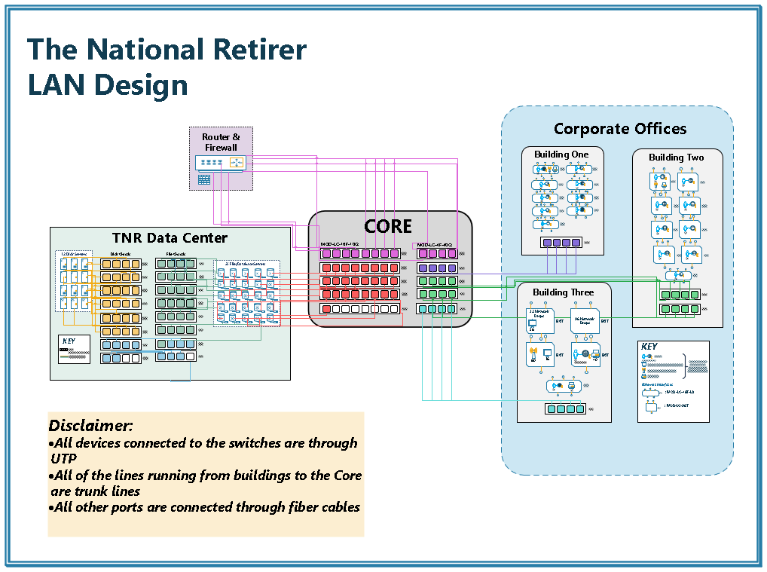

The core consists of ten switches. On the right side, there are five total MOD-LC-4F-40G switches. On the left side, there are a total of five MOD-LC-16-10G switches. All connections are color-coordinated to help visually represent what part of the network the cables are connected to.

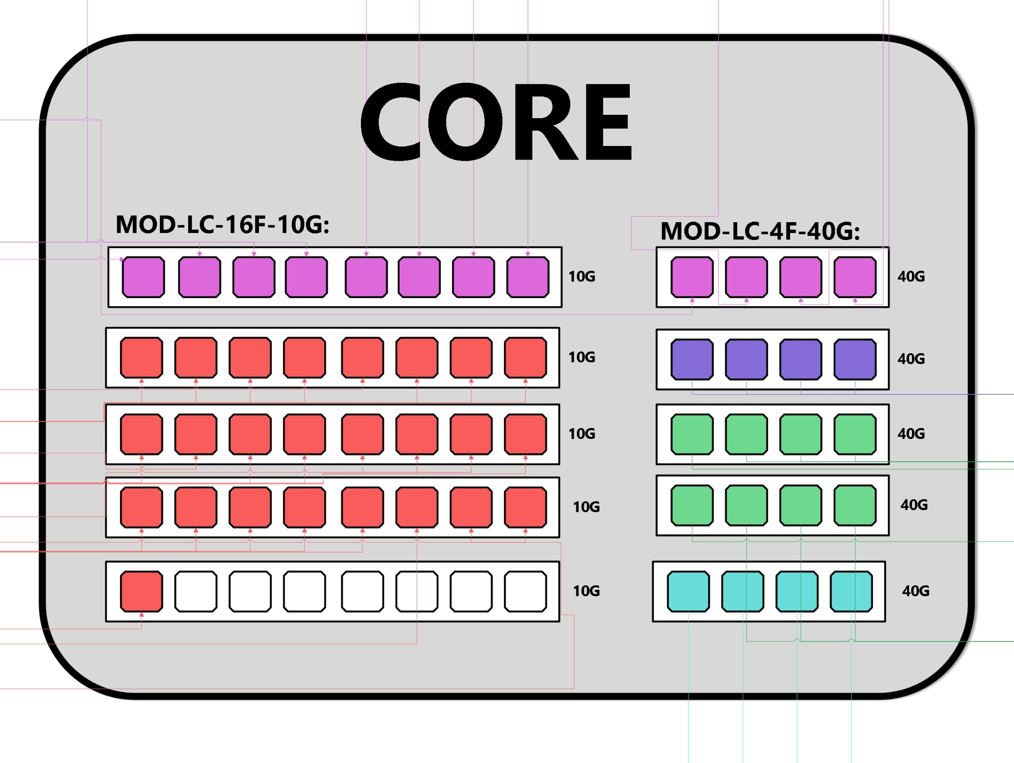

The Data Center has 12 dedicated disk servers that are only accessible by the 25 file/database servers through a private network. The 25 file/database servers are connected to the Core. The blue cables represent the connection between the disk and file chassis.

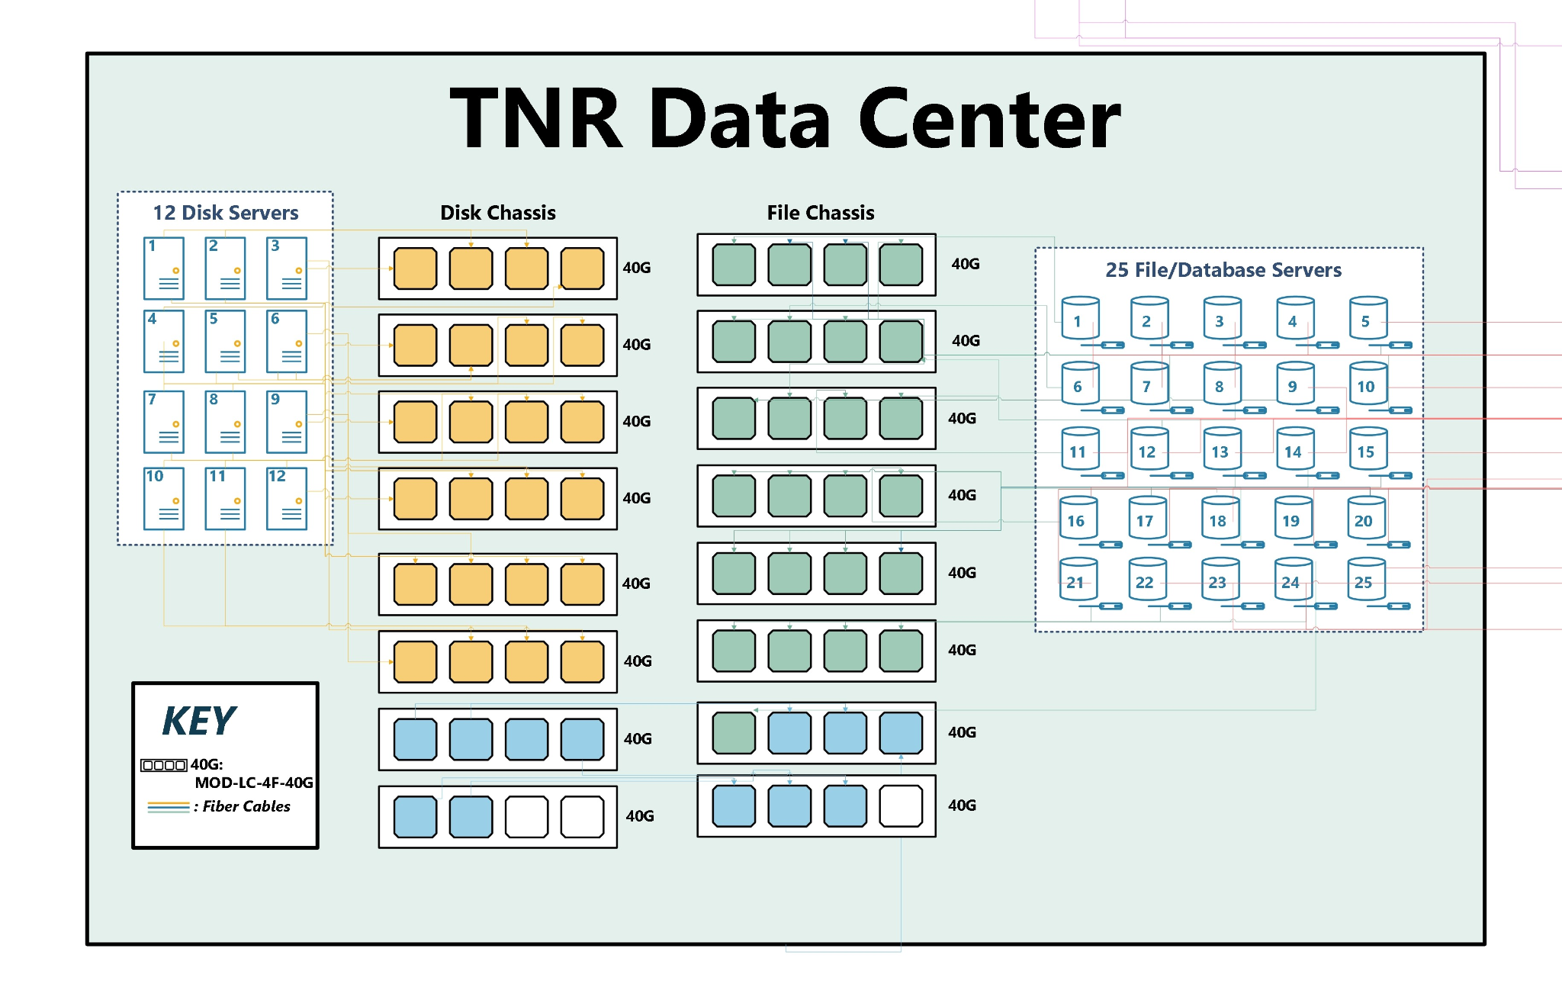

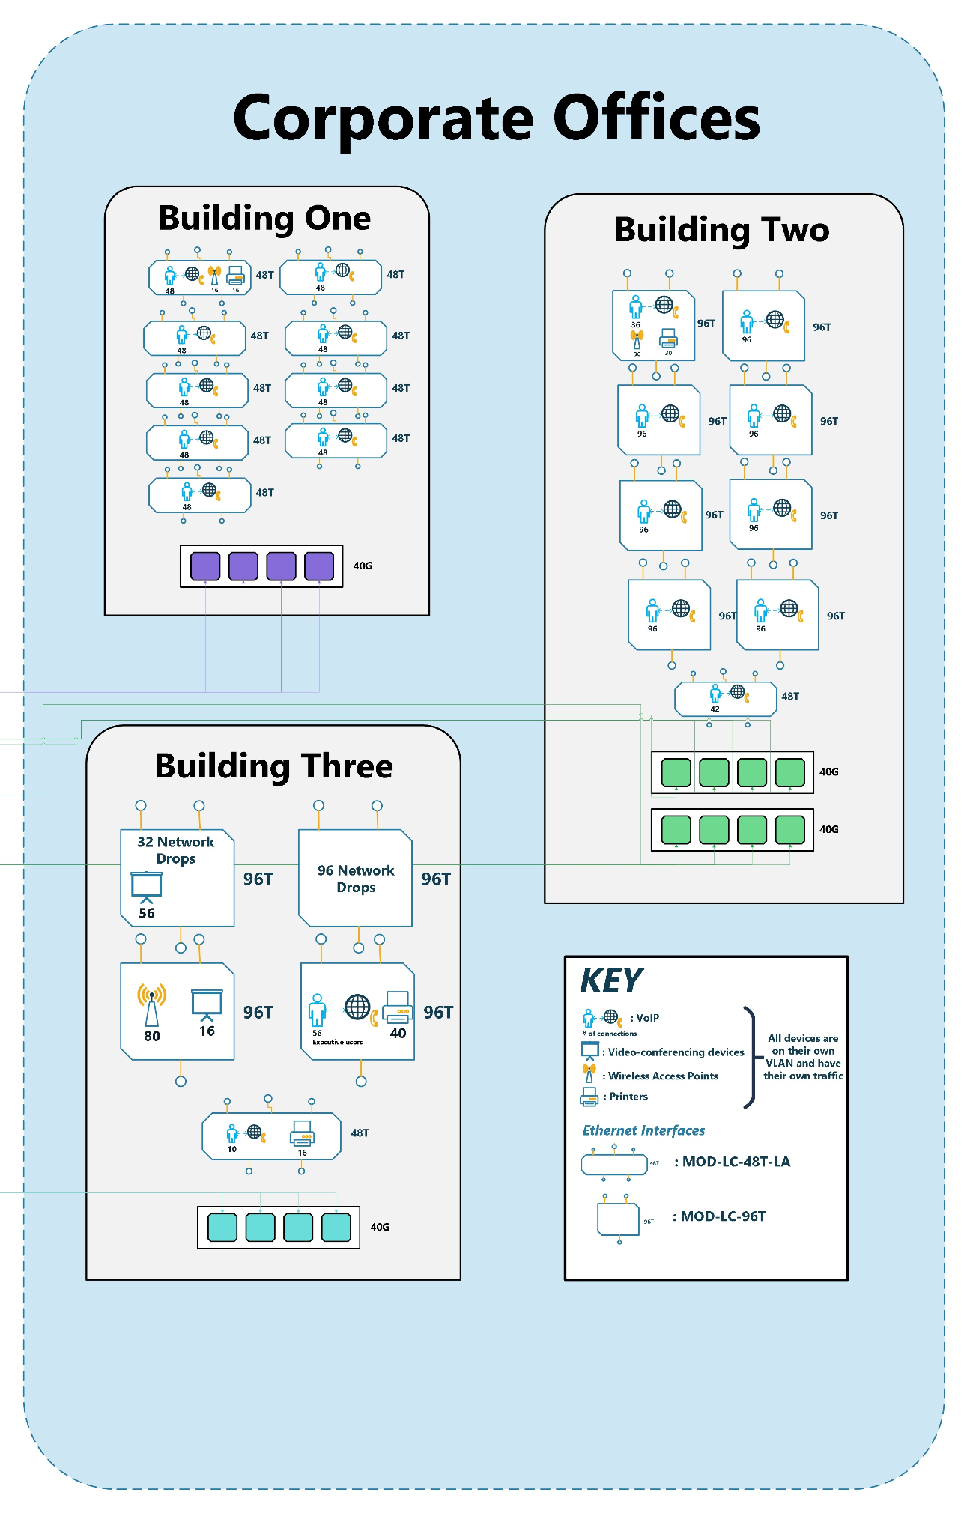

## Section 3 – Solution Analysis

We have provided what we believe to be a thorough network design for The National Retirer. We have taken into account the requirements that were provided to us as well as made reasonable assumptions about parts of the requirements document that did not specify measurements or quantities. The network design we created satisfies the requirements that were given to us. The TNR are not paying more for something they do not need. Neither are they paying for something that does not work for them.

The switches and cables we used for the network design, we believed were appropriate and would provide the best performance. Using the modular switches on the chassis allowed for all traffic coming from users and other connected devices to be in one place. By partitioning off the ports on the switches with VLANs, we were able to separate the incoming traffic from all devices, preventing any collisions from occurring. By using the MOD-LC-4F-40G in conjunction with the MOD-LC-48T and MOD-LC-96T, we limited the number of cables that would be routed to the network core. Taking this approach allows for all of the traffic to be in one physical location while keeping the traffic going to and from the devices separate based on their tasks. When doing the calculations for the bandwidth requirements of Buildings 1 and 3, the total bandwidth was a few Gbps over what our MOD-LC-4F-40G connecting to our core could handle. Instead of spending more on switches that would overperform what we needed, we chose to keep the number of switches the same. The calculations we performed were based on whether every user in the building as well as all of the devices were being used at the same time, the likelihood of this happening is very low. Because of this, we decided that the cost was not worth accommodating for a rare occurrence.

The Data Center, being an important part of the network, was given high priority when constructing a separate network to handle traffic as well as connecting the servers to the main network through the core. Due to the high priority and the high transmission rate each disk server and file server required, a lot of the budget was used here for the switches that transferred the data as well as the cables that connected the servers. We made the deduction that since 75% of the traffic that was being transferred to and from the Disk Servers came from another Disk Server, we would only have to accommodate for the 25% of traffic when making a network that connected to the File servers. This not only reduces the costs of the entire network design, but it also does not put in place an unnecessary amount of transfer rate that is not needed.

The network core connects all of the buildings and the data center. For it to be able to support all of the traffic that is going through the network, as well as going outside the network, switches with high bandwidth on the backplane and high uplink were needed. With this consideration, we created the core using MOD-LC-4F-40G switches to connect the buildings, creating the backbone of our network. MOD-LC-8F-10G switches are also used to connect the servers to the core. A mix of both switches is used to connect the router to the core as well. Creating a strong network core ensures that we will be able to handle all traffic occurring on our network. MOD-LC-8F-10G switches were chosen because the connection between the servers and core does not require a big transmission rate between the two, saving on costs and providing an appropriate amount of bandwidth.

The decision to use NAT with our network design was because it would make the network more manageable with our structure than if we decided to go with subnetting the addresses provided. With how our network was designed, subnetting would have been difficult due to the sizes of our VLANs not factoring well with the subnetting. If we wanted our network to use the provided IPs, we would have to use multiple subnets just for one floor of one building, making the whole subnetting pointless. With the use of NAT, we can bypass this issue and distribute our VLANs appropriately.

For the final design, we decided that using modular switches was the best option. This is primarily due to connecting the different chassis using modular switches requiring fewer cables than if we used fixed configuration connections. It gave us flexibility that allowed us to make a design that worked best for TNR. We used a tiered structure for the organization. The root switch is out network core with the lower tiers being the building chassis that houses all the switches. We chose to use NAT to simplify the process of separating our network and for the ease of maintaining the network.

## 

## Summary

Building 1 would have a MOD-SW-13 Chassis that would house one MOD-SW-SUP, nine MOD-LC-48T to connect the users and the devices in the building, and one MOD-LC-4F-40G to connect the building to the core. To connect all of the devices to the switches, 432 UTP cables are required. The connection to the core requires 4 fiber cables.

Building 2, from floors 2-4, also uses a MOD-SW-13 chassis to house one MOD-SW-SUP, eight MOD-LC-96T, one MOD-LC-48T, and two MOD-LC-4F-40G. The 96-port and 48-port switches are used to connect the users and devices to the network while the MOD-LC-4F-40Gs are used to connect the building to the rest of the network. Connecting the users and devices to the switches requires a total of 750 UTP cables. To connect building two to the rest of the network requires 8 fiber cables.

The first floor of building 2 also has the data center and network core. The data center will have two MOD-SW-13 (One that connects to the Disk Servers and one that connects to the file servers), four MOD-SW-SUP (2 per chassis for redundancy), sixteen MOD-SW-4F-40G (Each chassis will have eight to connect to the disk and file servers as well as connect the chassis’ together). To connect the disk servers and file servers to their chassis and the chassis together, 55 fiber cables are required.

The network core on floor one has a MOD-SW-13 chassis, it has two MOD-SW-SUP for redundancy, five MOD-LC-8F-10G, and five MOD-LC-4F-40G. 25 ports on the MOD-LC-8F-10G are used to connect the core to the file servers. One MOD-LC-8F-10G and one MOD-LC-4F-40G are used to connect the router and the rest of the MOD-LC-4F-40G are used to connect the three buildings' chassis’ to the network core. 37 Fiber cables are needed to connect everything.

Building 3 also has a MOD-SW-13 chassis that contains a MOD-SW-SUP, four MOD-LC-96T, one MOD-LC-48T, and one MOD-LC-4F-40G. The MOD-LC-96T and MOD-LC-48T are used to connect the users and devices to the network. The MOD-LC-4F-40G is used to connect the building 3 chassis to the network core. To connect all of the users and devices to the switches would require 402 UTP cables. Connecting the chassis to the network core requires 4 fiber cables.

The final cost of all the switches and cables is **$2,795,800**.

We separated our network using VLANs so traffic could be separated reducing potential collisions. We achieved this by subnetting our network using NAT for the ease of subnetting as well as maintaining the network without having too many VLANs or subnets. We have 6 VLANs and subnetted our network into 7 different sections (The additional subnet is for the Database Server connecting to our Network Core). The User's VLAN is on subnet 10.0.0.0/21, the VoIP VLAN is on 10.0.4.0/21, the Wireless Access Point VLAN is on subnet 10.0.16.0/25, the printer VLAN is on the subnet 10.0.16.0/25, the teleconference devices VLAN is on the subnet 10.0.17.0/25, building 3’s VoIP phone VLAN is on the Subnet 10.0.17.128/25, and the connections to the database are on the subnet 10.0.18.0/27.

The User’s and VoIP VLANs are large enough to accommodate all of the connections over the entire network and not just the building. We created the VLANs as such to separate the traffic while keeping our network organized.